May 2023

Sunday | Monday | Tuesday | Wednesday | Thursday | Friday | Saturday
 | May Holidays:  14th – Mother’s Day  17th – Syttende Mai  29th – Memorial Day | May Outing Information:  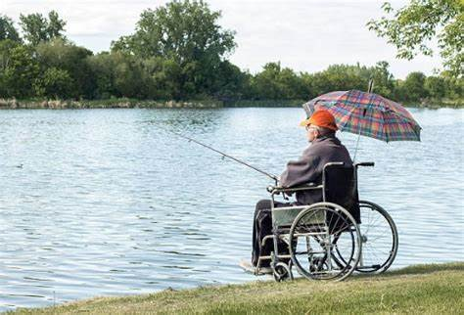  We have two outings this month!  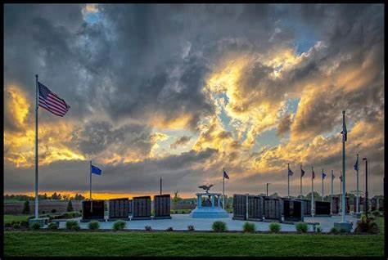  Where: Fishing @ Lake Kegonsa Where: Stoughton Veteran’s Memorial  When: Tuesday, May 16th @ 8:30 am When: Tuesday, May 23rd @ 11:00 am  Contact Keri at ext. 7215 or in person Skaalen Veterans get first priority of this outing! If interested in attending the outing. Please let Keri know if you have any questions.
Join Chaplain James in the Chapel or on Ch. 900 every Monday - Thursday @ 11 am for Chapter of the Day. | 1  10:00 – Mother’s Day Craft  (Activity Room)  1:30 – Bingo  (Community Room) | 2  10:30 – Resident Council  (Chapel)  2:00 – Air Hockey  (Community Room) | 3  10:00 – Euchre  (Kaffe Stue)  1:30 – Uno  (Community Room) | 4  10:00 – 1:1 Visits  (Outside)  1:00 – Men’s Group  (Kaffe Stue)  2:00 – Concert:  Craig Seimsen  (Chapel/Ch.900) | 5  10:00 – 1:1 Visits  (Outside)  2:00 – Kentucky Derby Party  (Community Room) | 6
7  10:00 – Worship Service  (Chapel/Ch. 900) | 8  10:00 – Manicures  (Community Room)  1:30 – Movie  & Popcorn  (Chapel) | 9  10:00 – Hymn Sing  (Chapel)  2:00 – Tie-Dying  (Activity Room) | 10  10:00 – Baking Group  (Activity Room)  1:30 – Bingo  (Community Room) | 11  10:00 – Vietnam Vets Recognition  (Chapel/Ch.900)  2:00 – Concert:  Gemini Entertainment  (Chapel/Ch. 900) | 12  10:00 – Norwegian Craft  (Kaffe Stue)  2:00 – Mother’s Day Party  (Community Room) | 13
May 2023

Sunday | Monday | Tuesday | Wednesday | Thursday | Friday | Saturday
14  10:00 – Worship Service  (Chapel/Ch. 900)  Mother’s Day | 15  10:00 – James Book Presentation  (Chapel/Ch.900)  1:30 – Bingo  (Community Room) | 16  8:30 – Fishing Trip  (Therapy Entrance)  2:00 – Tie-Dying  (Community Room) | 17  9:30 – King & Queen Visits  (Therapy Entrance)  10:00 – Norwegian Dancers  (Therapy Entrance)  1:30 – Bingo  (Community Room)  Syttende Mai | 18  10:00 – Mass  (Chapel/Ch.900)  2:00 – Kaffe Lag  (Community Room) | 19  10:00 – 1:1 Visits  (Outside)  2:00 – Concert: Schann’s Comedy Jazz Show  (Chapel/Ch. 900) | 20
21  10:00 – Worship Service  (Chapel/Ch. 900) | 22  10:00 – Memorial Day Craft  (Community Room)  1:30 – Movie  & Popcorn  (Chapel) | 23  10:00 – Hymn Sing  (Chapel)  11:00 – Stoughton Veteran’s Memorial  (Outing)  Contact Keri at ext. 7215 or in person if interested. | 24  10:00 – Baking Group  (Activity Room)  1:30 – Bingo  (Community Room) | 25  10:00 – Devo & Donuts  (Kaffe Stue)  2:00 – Concert: Bahama Bob  (Chapel/Ch. 900) | 26  10:00 – Exercise  Group  (Community Room)  2:00 – Memorial Day Party  (Community Room) | 27  2:00 – Concert: Blue Moon Klezmer Band  (Chapel/Ch. 900)
28  10:00 – Worship Service  (Chapel/Ch. 900) | 29  Memorial Day | 30  10:00 – Coffee & Cookies  (Community Room)  2:00 – Noodle Hockey  (Community Room) | 31  10:00 – Euchre  (Kaffe Stue)  1:30 – Bingo  (Community Room) | Type of Activity  Cognitive  Emotional Physical  Social  Spiritual | Director of LSS: Keri Wright  LSS Assistant: Tina Kunjo Chaplain: James Salimes  Church & Community Relations: Dawn Zaemisch

